*A FINAL PROJECT REPORT ON*

**ANOMALY RECOGNITION FROM SURVEILLANCE**

**VIDEOS USING CONVOLUTION NEURAL NETWORK**

# by

**SIRIPURAPU YESWANTH**

## ABSTRACT

Video Surveillance plays a pivotal role in today’s world. The technology has been developed to much in every sector of all departments much when artificial intelligence, machine learning and deep learning pitched into the system. Using the above combinations, different systems are in place which helps to differentiate various suspicious behaviours from the live tracking of footages. The most unpredictable one is human behaviour and it is very difficult to find whether it is suspicious or normal because it occurs every day in our day-to-day life. Deep learning approach is used to detect suspicious or normal activity in an academic environment, and which sends an alert message to the corresponding authority, in case of predicting a suspicious activity. Monitoring is often performed through consecutive frames which are extracted from the video. The entire framework is divided into two parts. In the first part, the features are computed from video frames and in second part, based on the obtained features classifier predict the class as suspicious or normal.

**TABLE OF CONTENTS**

|  |  |  |
| --- | --- | --- |
| **CHAPTER NO.** | **TITLE** | **PAGE NO.** |
| **1.** | **1.1 INTRODUCTION** | **6** |
|  | **1.2 OVERVIEW** | **6** |
|  | **1.3 PROJECT STATEMENT** | **7** |
|  | **1.4 OBJECTIVE** | **7** |
|  | **1.5 SCOPE OF THE PROJECT** | **7** |
| **2.** | **2.1 EXISTING SYSTEM** | **8** |
|  | **2.2 HARDWARE AND SOFTWARE INTERFACE** | **8** |
| **3.** | **3.1 SURVEY AND PUBLISHERS BASED ON ANOMALY**  **DETECTION USING CNN AND DEEP LEARNING** | **9** |
|  | **3.2 LITERATURE SURVEY AND MAIN ENTITIES IN ANOMALY**  **DETECTION** | **10** |
| **4.** | **4.1 PROPOSED SYSTEM**  **4.2 RESNET 18 CNN FOR ANOMALY DETECTION FROM**  **VIDEO SURVILLANCE** | **12**  **12** |
| **5.** | **5.1 EXPERIMENT SET AND DATA SET**  **5.2 RESNET 18 ARCHITECTURE WITH FRAME SIZE OUTPUT**  **5.3 SAMPLE ANOMALY VIDEOS IN UCF CRIME DATASET**  **5.4 TRAINING AND TESTING SET UP** | **16**  **18**  **19**  **20** |
| **6.** | **IMPLEMENTATION AND RESULTS** | **21** |
| **7.** | **CONCLUSION AND FUTURE WORKS** | **36** |
|  | **REFERENCES** | **37** |

**CHAPTER 1**

## 1.1 INTRODUCTION

Action Recognition, a sub space of vision related applications, is the capacity to distinguish and perceive the activities or objectives of the specialist, the specialist can be any item or substance that performs activity, which has ultimate objectives. The specialist can be a solitary specialist playing out the activity or gathering of specialists playing out the activities or having some communication. One such illustration of the specialist is human itself and perceiving the action of the people is called as Human Activity Recognition. Video Surveillance assumes a vital part in this day and age. The innovations have been progressed an excess of when manmade brainpower, AI and profound learning pitched into the framework. The most capricious one is human way of behaving and it is truly challenging to track down whether it is dubious or ordinary. Profound learning approach is utilized to distinguish dubious or ordinary movement in a scholastic climate, and which sends an alarm message to the comparing authority, in the event of foreseeing a dubious action. Observing is much of the time performed through sequential edges which are extricated from the video. The whole system is isolated into two sections. In the initial segment, the elements are registered from video outlines and in second part, in light of the got highlights classifier foresee the class as dubious or ordinary.

## 1.2 OVERVIEW

The Overview of the project undertaking is the recently detailed work distinguishes a specific a typical action, for example, savagery identification where significant subsidiary conditions are utilized as video descriptors to ascertain nearby and convective speed increase (force) to recognize brutality from swarmed places. The objective of human action acknowledgment is to naturally break down continuous exercises from an obscure video (i.e., an arrangement of picture outlines).

## 1.3 PROJECT STATEMENT

For every person in this world may see the different types anomaly incidents occurs and they didn’t even see in a short period of time which it occurs by using the different type of approaches are now available like deep learning, machine learning, AI, etc. By using this we can easily predict at which particular time the incident occurs and it also helpful to give accuracy results.

## 1.4 OBJECTIVE

The main objective of the project can anticipate dubious or ordinary human conduct in the recording which is utilized to help the observing system. The majority of the ongoing framework utilizes the recordings acquired from CCTV cameras. On the off chance that any wrongdoing or viciousness occurs, this video will be utilized for examination reason. Yet, assuming that we consider a framework which will consequently distinguishes what is happening ahead of time and an instrument to caution the separate authority is really fascinating and which can be applied to indoor and outside places.

## 1.5 SCOPE OF PROJECT

The main scope of the project is there is a quick development in the quantity of camcorders at public and confidential area as a result of the checking and security purposes. As video observation is in blast these days, it has got more examination consideration because of expanded worldwide security concerns. This quickly developing information can be utilized to naturally identify the abnormal exercises which are going around in our encompassing in everyday life. Atypical movement is something that goes astray from its generally expected nature or something that goes against the ordinary occasions. This venture primarily centres around recognizing peculiar exercises in jam-packed scenes by utilizing video information. It serves to Automatically distinguishing the odd movement without utilizing the handmade component has turned into the need of great importance.

**CHAPTER 2**

## 2.1 EXISTING SYSTEM

This problem is does not affect not only the Human behaviour conduct discovery in video reconnaissance framework is a mechanized approach to astutely identifying any dubious movement. Video observation is the arising region in the utilization of Artificial Intelligence, Machine Learning and Deep Learning. Man-made brainpower assists the PC with thinking like human. Number of proficient calculations is accessible for the programmed discovery of human conduct in open regions like air terminals, railroad stations, banks, workplaces, assessment lobbies and so on In AI, significant parts are gaining from the preparation information and make expectation on future information. These days GPU (Graphics Processing Unit) processors and tremendous datasets are accessible, so the idea of profound learning is utilized. PC vision techniques includes the accompanying stages: demonstrating of conditions, location of movement, grouping of moving articles, following, conduct understanding and portrayal, and combination of data from different cameras. The mix of PC vision and video reconnaissance will guarantee public wellbeing and security. This strategy requires part of pre-handling to extricate highlights in various video arrangements. The characterization procedures are administered and unaided arrangement. Regulated grouping utilizes physically named preparing information while solo arrangement is completely PC worked and require no human intercession.

## 2.2 HARDWARE & SOFTWARE INTERFACE

The minimum requirements for hardware and software interface for the project is

1. System: Pentium i3 Processor.
2. Hard Disk: 500 GB.
3. Monitor: 15’’ LED
4. Input Devices: Keyboard, Mouse
5. Ram: 2 GB
6. Operating system: Windows 10.
7. Coding Language: Python Idle

## CHAPTER 3

**3.1 SURVEY AND PUBLISHERS BASED ON ANOMALY DETECTION USING CNN**

**AND DEEP LEARNING**

•Ahmed Taha, Halazayed [1] 2021 proposed a framework for human movement acknowledgment. The proposed framework presents a human action descriptor in light of the people skeletal data of the human action is invariant to the size of the subject and the direction of camera. Secret Markov Models are utilized to perceive human exercises. For every action class, a HMM is learned. Analyse completed on two benchmark datasets: Cornell CAD-60 and Cornell CAD-120.

* Wei a Deng [2] 2020 researches the skeletonization issue utilizing equal diminishing strategies and propose another one pass equal lopsided diminishing calculation. Wu and Tsai introduced a one-pass equal uneven diminishing calculation that executed 4-distance, or city block distance, skeletonization. By applying 8-distance, or chessboard distance, this new calculation works on the nature of the subsequent skeletons as well as the effectiveness of the calculation. This calculation utilizes 18 examples. The proposed OTPA8 has great commotion obstruction, totally 8-associated skeleton output and a quicker speed without genuine disintegration.

* B. Yogameena, S. Veera Lakshmi 2019[3] proposed a constant video observation framework which is fit for characterizing ordinary and unusual activity of people in swarm. The strange activity of human, for example, running, hopping, waving hand, twisting, strolling and battling with one another in a packed climate are thought of. In this paper, Relevance Vector Machine (RVM) is utilized to group the unusual activities of individual in swarm in light of the outcomes got from projection and skeletonization strategies.

**3.2 LITERATURE SURVEY AND MAIN ENTITIES IN ANOMALY DETECTION**

Classification of Activity recognition can be based on multiple parameters. This taxonomy has been well explained in [2] and stated diagrammatically below.

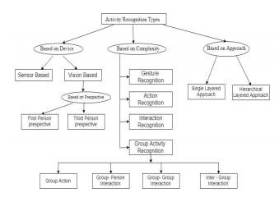

A. Sorts of Activity Recognition in light of gadgets utilized: Based on the gadgets utilized in the framework, Activity Recognition is named sensor-based movement acknowledgment and vision-based action acknowledgment.

1. Sensor based action acknowledgment utilizes organization of sensors to screen the way of behaving of an entertainer, and some screen the environmental factors. . They are additionally utilized for preparing the model utilizing various information examination, AI and profound learning procedures. Such information gathered from different sensors might be totaled and handled to get some fundamental data from them.

1. Vision based activity recognition these systems normally use computerized picture handling to extricate significant data from the video, which is considered as sequence of images.

B. Sorts of Activity Recognition in view of Complexity:

1. Gesture Recognition - Signals are rudimentary developments of an individual's body parts, and are the nuclear parts depicting the significant movement of an individual. "Extending an arm" and "raising a leg" are genuine instances of motions.
2. Action Recognition – Activities are single-individual exercises that might be made out of various signals coordinated transiently, for example, such as “walking,” “waving,” and “punching, fighting, explosion.”
3. Interaction Recognition - Cooperation’s are human exercises that include at least two people as well as articles. For instance, “two persons fighting" is a communication between two people and "an individual giving over a bag to another" is a human-object collaboration including two people and one article.
4. Group Activity Recognition – This involves activities performed by a group of actors, a person interacting with the group, two groups interacting with each other and people within a group interacting with each other.

C. Types of Movement Recognition in light of point of view

1. First individual point of view – An instance that can be thought of is of a situation where two people are interacting with each other, one of which has worn a head mounted camera which records the video for further processing. This means one of the persons engaged in performing the activity will also be engaged in capturing the video.
2. Third individual point of view –Here, the observing entity and the performing entity are different. The camera mounted at a static point, which is recording the interaction between two people forms a Third individual point of view

D. Types of Movement Recognition in view of Approaches

1. Single Layered Approach A simple example would be a person extending hand. involves identifying the primary activities or independent activities that are directly obtained from the video
2. Progressive Approach includes recognizing set of sequential but atomic activities which when aggregated forms a different activity.

**CHAPTER 4**

## 4.1 PROPOSED SYSTEM

Taking Anomaly occurrences and recordings the proposed arrangement will utilize recordings got from CCTV camera for observing the human conduct in a grounds and tenderly caution when any dubious occasion happens. The significant parts in astute video observing are occasion location and human conduct acknowledgment. Programmed comprehension of human way of behaving is a difficult errand. In a grounds, various regions are under video reconnaissance and different exercises are to be observed. The video film got from grounds has been utilized for testing. The whole course of preparing an observation framework can be summed up in to three stages: information readiness, preparing the model and deduction. CNN is utilized to remove significant level elements from the pictures with the goal that the intricacy of the information can be decreased. The proposed framework is utilizing a pre-prepared model called RESNET 18 which is prepared on the ImageNet dataset. As of now, model is preparing in such a method for anticipating conduct from the recording.

## 4.2 RESNET 18 CNN FOR ANOMALY DETECTION FROM VIDEO SURVILLANCE

For this project we are using RESNET 18 Convolution Neural Network due to it is a convolutional brain network that is 18 layers profound. You can stack a pretrained rendition of the organization prepared on in excess of 1,000,000 pictures and recordings from the ImageNet information base. It gives alternate way associations which settle the issue of disappearing angle. The model is prepared and tried effectively giving a palatable outcome by perceiving more than 400 human activities. At last, a few open issues are introduced which ought to be tended to in future examination.

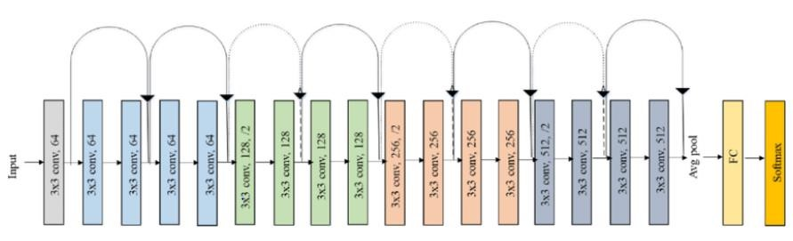

*Fig 4.2.1 Original Resnet 18 CNN Architecture*

The architecture of this network aimed at enabling large amounts of convolutional layers to function efficiently. The addition of multiple deep layers to a network often results in a degradation of the output.

**4.2.2 FLOW CHART FOR THE ANOMALY DETECTION USING RESNET 18 CNN:**

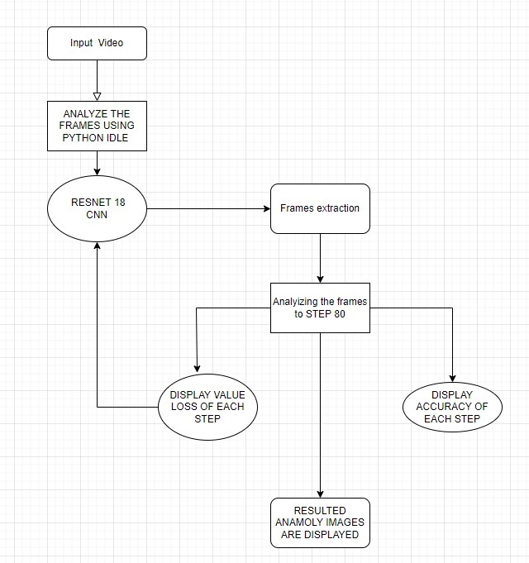

*Fig 4.2.2 Flow chart diagram of anomaly detection using Resnet 18 CNN*

Activity diagrams are graphical representations of workflows of stepwise activities and actions with support for choice, iteration and concurrency. From this Activity Diagram first we have input the video and later analyse the frames using Resnet 18 the frames should be extracted and it displays loss and accuracy of video of anomaly is displayed and later the respective anomaly frames are shown as result.

**4.2.3 SEQUENCE DIAGRAM FOR ANOMALY DETECTION USING RESNET 18 CNN:**

Input Video Frame

Get Frame

Pre Processing

Feature Extraction

Classification

()

: webcam

1

2

: drivernotworking

()

3

: filtering_noise_removal

()

4

: construct feature vector

()

5

: abnormal_event

()

*Fig 4.2.3 Sequence diagram for Anomaly Detection using RESNET 18 CNN*

A Sequence diagram in Unified Modelling Language (UML) is a kind of interaction diagram that shows how processes operate with one another and in what order. It is a construct of a Message Sequence Chart. Sequence diagrams are sometimes called event diagrams, event scenarios, and timing diagram.

**CHAPTER 5**

## 5.1 EXPERIMENT SETUP AND DATA SET

* UCF Crime Anomaly Detection Dataset • 1,900 real-world surveillance videos of 128 hours
* 15 times more videos than existing datasets.
* 13 real-world anomalies

|  |  |  |  |  |
| --- | --- | --- | --- | --- |
|  | # Of videos | Average frames | Dataset length | Example anomalies |
| UCSD Ped1[27] | 70 | 201 | 5 min | Bikers, small carts, walking across walkways |
| UCSD Ped2[27] | 28 | 163 | 5 min | Bikers, small carts |
| Subway Entrance  [3] | 1 | 121,749 | 1.5 hours | Wrong direction,  No payment |
| Subway Exit [3] | 1 | 64,901 | 1.5 hours | Wrong direction,  No payment |
| Avenue [28] | 37 | 839 | 30 min | Run, throw, new object |
| UMN [2] | 5 | 1290 | 5 min | Run |
| BOSS [1] | 12 | 4052 | 27 min | Harass, Disease,  Panic |
| **Ours** | **1900** | **7247** | **128 hours** | **Abuse, arrest, arson, assault, accident, burglary, fighting, robbery** |

|  |  |
| --- | --- |
| **ANOMALY** | **NUMBER OF VIDEOS** |
| BURGLARY | 100 |
| FIGHTING | 50 |
| ROAD ACCIDENTS | 150 |
| ROBBERY | 150 |
| SHOOTING | 50 |
| SHOP LIFTING | 50 |
| STEALING | 100 |
| ABUSE | 50 |
| ARREST | 50 |
| ARSON | 50 |
| ASSAULT | 50 |
| EXPLOSION | 50 |
| VANDALISM | 50 |
| NORMAL | 950 |

## 5.2 Resnet 18 Architecture with frame size of output

|  |  |  |
| --- | --- | --- |
| **LAYER NAME** | **Output Size** | **ResNet-18** |
| conv1 | 112 x 112 x 64 | 7 x 7, 64, stride 2 |
| conv2_x | 56 x 56 x 64 | [3 × 3, 64 3 x3, 64] x 2 |
| conv3_x | 28 x 28 x 128 | [3 x 3, 128 3 x3, 128] x 2 |
| conv4_x | 14 x 14 x 256 | [3 x 3,256 3 x 3,256] x 2 |
| conv5_x | 7 x 7 x 512 | [3 x 3,512 3 x 3,512] x 2 |
| average pool | 1 x 1 x 512 | 7 x 7 average pool |
| fully connected | 1000 | 512 x 1000 fully connections |
| Soft max | 1000 |  |

**5.3 SAMPLE ANOMALY VIDEOS IN UCF CRIME DATSET:**

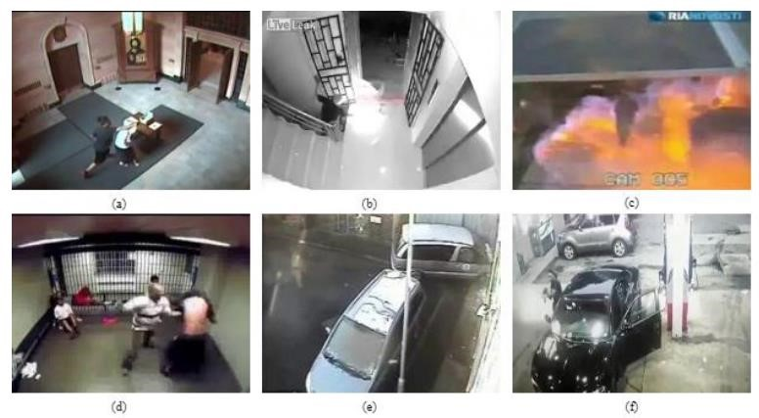

*Fig 5.3 Sample anomalous frames from UCF Crime Dataset (a) Abuse (b) Arson (c) Explosion (d) Fight (e) Road Accident (f) Shooting*

**5.4 TRAINING AND TESTING SETUP:**

Each class of this dataset contains just 38 recordings in its preparation set which are not adequate for exact model learning. To conquer this limit, we increase every video spatially as examined in the expansion area. The insights of the spatially increased dataset are given above in Table 2 where most extreme and least video cut lengths are introduced for preparing set as it were. We roll out no improvement in the test set of the UCF Crime dataset hence it comprises of 168 recordings. The preparation and testing set of this dataset involve each of the 13 strange classes and ordinary class recordings. Each bizarre class is discriminative enough because of edge level comment. Additionally, the edge dispersion of the preparation set utilized in our investigation after spatial increase and length are displayed in Figure 5.4. Additionally, the edge circulation of the UCF Crime preparing set.

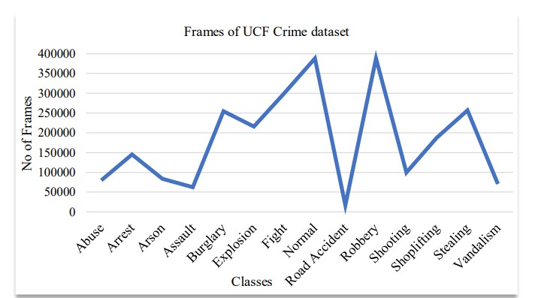

*Fig 5.4 Appropriation of casings in the preparation set of UCF Crime*

**CHAPTER 6**

## IMPLEMENTATION AND RESULTS

PYTHON CODE:

import tkinter as tk

from tkinter.filedialog import askopenfilename import handling as pc from PIL import Image, ImageTk from tkinter import * from tkinter import messagebox from tkinter import * from PIL import ImageTk, Image from tkinter import filedialog import cv2 import numpy as np from matplotlib import pyplot as plt import cv2 import glob import os,fnmatch from skimage.data import coins

from skimage.morphology import mark, remove_small_objects from skimage.measure import regionprops, find_contours from sklearn.model_selection import train_test_split import pandas as pd import numpy from scipy import details

#from sklearn.grid_search import RandomizedSearchCV

from sklearn.model_selection import RandomizedSearchCV#from sklearn.grid_search import GridSearchCV from sklearn.model_selection import GridSearchCV from sklearn.preprocessing import MinMaxScaler from sklearn.preprocessing import MaxAbsScaler import tkinter.scrolledtext as st import tkinter.scrolledtext as scrolledtext from sklearn.svm import SVC from skimage.measure import compare_ssim import warnings

image_file = None originimage = None proceimage = None

def resize(w, h, w_box, h_box, pil_image):

f1 = 1.0 * w_box/w # 1.0 powers float division in Python2 f2 = 1.0 * h_box/h factor = min([f1, f2])

# print(f1, f2, factor) # test

# utilize best down-estimating channel width = int(w * factor) level = int(h * factor)

return pil_image.resize((width, level), Image.ANTIALIAS)

def open_image(): global image_file filepath = askopenfilename()

############################################# cap = cv2.VideoCapture(filepath) if(cap.isOpened() == False):

print("Error Opening Video Stream Or File") while(cap.isOpened()): ret, frame =cap.read() if ret == True:

cv2.imshow('frame', frame) if cv2.waitKey(25) == ord('q'):

break else: break cap.release() cv2.destroyAllWindows()

print('Video Completed Frame Process started..');

################################################### vidcap = cv2.VideoCapture(filepath) success,image = vidcap.read() count = 0 import os

dir = "./Database/Test/Abuse"; for f in os.listdir(dir): os.remove(os.path.join(dir, f)) print('Abuse Removed') dir = "./Database/Test/Arrest"; for f in os.listdir(dir): os.remove(os.path.join(dir, f)) print('Arrest Removed') dir = "./Database/Test/Arson"; for f in os.listdir(dir): os.remove(os.path.join(dir, f)) print('Removed') dir = "./Database/Test/Assault"; for f in os.listdir(dir): os.remove(os.path.join(dir, f)) print('Assault Removed') dir = "./Database/Test/Burglary"; for f in os.listdir(dir):

os.remove(os.path.join(dir, f)) print('Burglary Removed') dir = "./Database/Test/Explosion"; for f in os.listdir(dir):

os.remove(os.path.join(dir, f)) print('Explosion Removed') dir = "./Database/Test/Fighting"; for f in os.listdir(dir): os.remove(os.path.join(dir, f)) print('Fighting Removed') dir = "./Database/Test/Normal"; for f in os.listdir(dir):

os.remove(os.path.join(dir, f)) print('Normal Removed') while success:

#cv2.imwrite("Database\\Train\\Abuse\\frame%d.png" % count, image) # save frame as JPEG file if count == 155: print('Start')

cv2.imwrite("Database\\Test\\Abuse\\frame%d.png" % count, image) # save frame as JPEG file

cv2.imwrite("Database\\Test\\Arrest\\frame%d.png" % count, image) # save frame as JPEG file

cv2.imwrite("Database\\Test\\Arson\\frame%d.png" % count, image) # save frame as JPEG file

cv2.imwrite("Database\\Test\\Assault\\frame%d.png" % count, image)

# save frame as JPEG file

cv2.imwrite("Database\\Test\\Burglary\\frame%d.png" % count, image)

# save frame as JPEG file

cv2.imwrite("Database\\Test\\Explosion\\frame%d.png" % count, image)

# save frame as JPEG file

cv2.imwrite("Database\\Test\\Fighting\\frame%d.png" % count, image)

# save frame as JPEG file

cv2.imwrite("Database\\Test\\Normal\\frame%d.png" % count, image) # save frame as JPEG file

#print("Database\\Train\\Burglary\\frame%d.png" % count, image) success,image = vidcap.read() print('Read a new frame: ', success)

count += 1

print('Frame Process Completed..');

image_file = Image.open("Database\\Test\\Abuse\\frame155.png") w_box = 500 h_box = 350

showimg(image_file, imgleft, w_box, h_box) showimg(image_file, imgright, w_box, h_box)

##############################################

def showimg(PIL_img, master, width, height):

w, h = PIL_img.size

img_resize = resize(w, h, width, height, PIL_img)

# Image 2 ImageTk

Tk_img = ImageTk.PhotoImage(image=img_resize)

master.config(image=Tk_img) master.image = Tk_img

def Otsu():

PIL_gary,PIL_Otsu = pc.Otus_hold(image_file) w_box = 500 h_box = 350

showimg(PIL_gary, imgleft, w_box, h_box) showimg(PIL_Otsu, imgright, w_box, h_box) histleft.config(image=None) histleft.image = None histright.config(image=None) histright.image = None

###############################################

def selection():

choice = var.get() if choice == 1: m = 'Low' elif choice == 2: m = 'High' elif choice == 3:

pass return m

def submit(): global res try:

name = int(name_Tf.get()) m = selection() if name <= 102:# and m=='Low': text=m+'Risk:1. Vitamin-C-34 2. Zinc-17 3. B-complex-17 4. Cloth Masks-6 5. Sanitizer-1 6. Liquid Hand Wash-1 7. Gloves-2pairs 8. Sodium Hypocholorate Solution-1 9. Home Isolation for 14 days 10. Dolo 650mg 11. mythaline-14 12. FabiFlu 800mg per Day' res=text

file1 = open("op.txt","w")

L = [m+"\n","Prescription::\n","1. Vitamin-C-34 \n","2. Zinc-17 \n","3. B-complex-17 \n","4. Cloth Masks-6 \n","5. Sanitizer-1 \n","6. Liquid Hand Wash-1 \n","7. Gloves-2pairs \n","8. Sodium Hypocholorate Solution-1 \n","9. Home Isolation for 14 days \n","10. Dolo 650mg \n","11. mythaline-14 \n ","12. FabiFlu 800mg per Day \n"]

file1.writelines(L) file1.close()

file1 = open("op.txt","r") res=file1.readlines() txt.insert(tk.INSERT,res) else:

text='HIgh Risk admit to the hospital' res=text

file1 = open("op.txt","w") L = [text+"\n"] file1.writelines(L) file1.close()

file1 = open("op.txt","r") res=file1.readlines() txt.insert(tk.INSERT,res)

return messagebox.showinfo('Result', text) except Exception as ep:

return messagebox.showwarning('Result', 'Please provide valid input')

def termsCheck(): if cb.get() == 1:

submit_btn['state'] = NORMAL else:

submit_btn['state'] = DISABLED

messagebox.showerror ('Result', 'other covid 19 symtpoms')

################################################################

######

def run():

import MAIN

root = tk.Tk() root.title('Abnormal') root.geometry('1100x700') root.config(bg='white')

menubar = tk.Menu(root)

filemenu = tk.Menu(menubar, tearoff=0)

filemenu.add_command(label='OPEN', command=open_image) work = tk.Menu(menubar, tearoff=0)

operate.add_command(label='OTSU',command=Otsu) operate.add_command(label='Classify',command=run)

menubar.add_cascade(label='FILE', menu=filemenu) menubar.add_cascade(label='Process', menu=operate)

frm = tk.Frame(root, bg='white')

frm.pack() frm_left = tk.Frame(frm, bg='white') frm_right = tk.Frame(frm, bg='white') frm_left.pack(side='left') frm_right.pack(side='right')

imgleft = tk.Label(frm_left, bg='white') histleft = tk.Label(frm_left, bg='white')

imgright = tk.Label(frm_right, bg='white') histright = tk.Label(frm_right, bg='white') imgleft.pack() histleft.pack() imgright.pack() histright.pack()

################################# root.config(menu=menubar) root.mainloop()

STEP 1: Open python idle (python idle 3,7-64bit) and select the code file

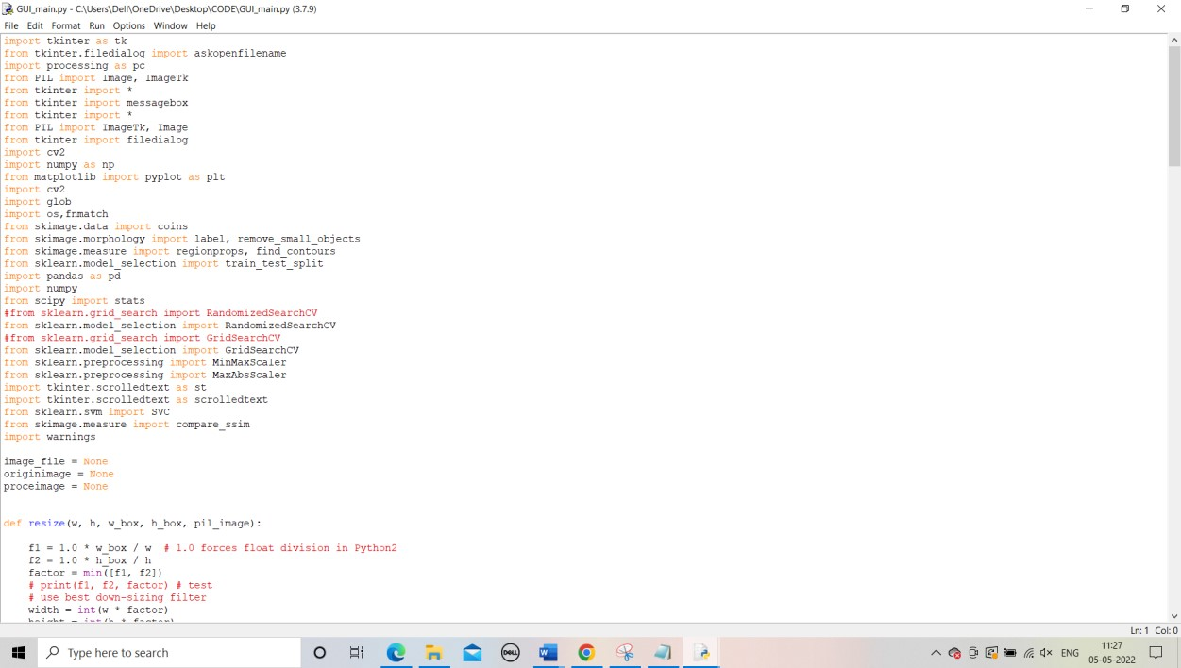

*fig 6.1 open code in python idle*

STEP 2: Run the module of code File

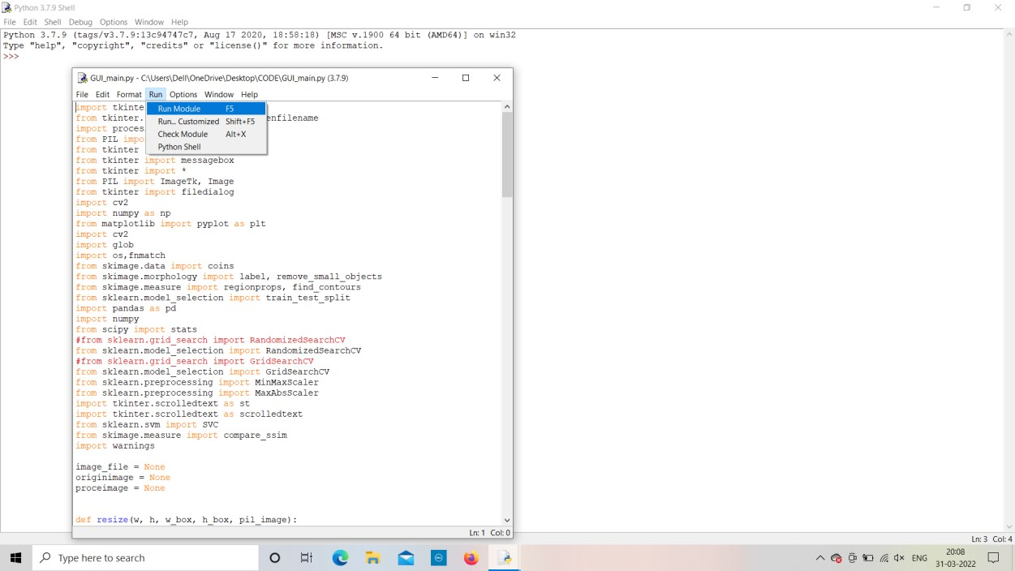

*fig 6.2 Run the module*  STEP 3: After that process import the input of sample video of Anomaly occurs

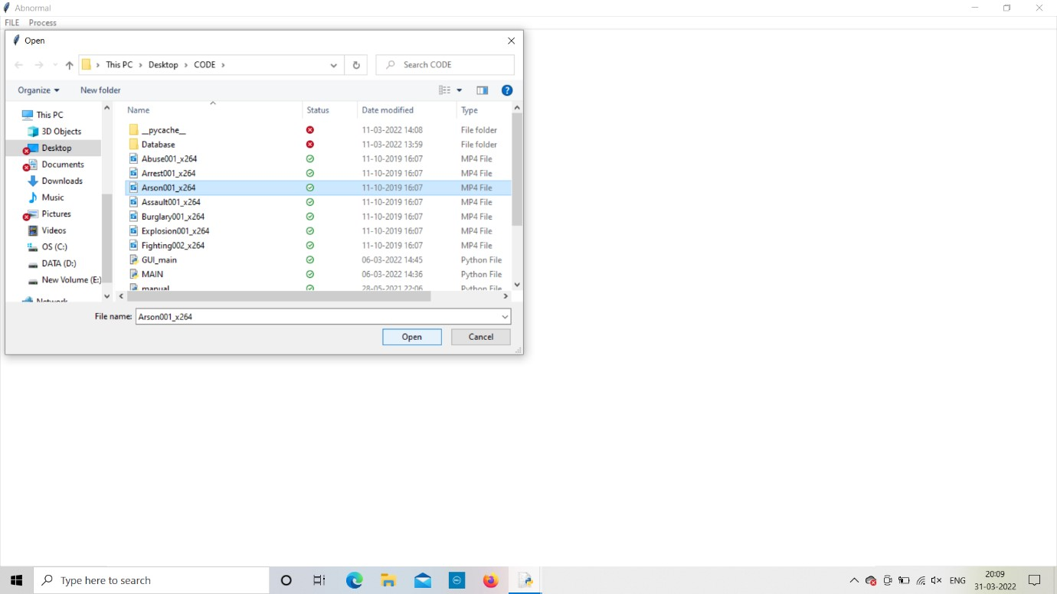

*fig 6.3 Input sample video*

STEP 4: Select the required input video whatever we want

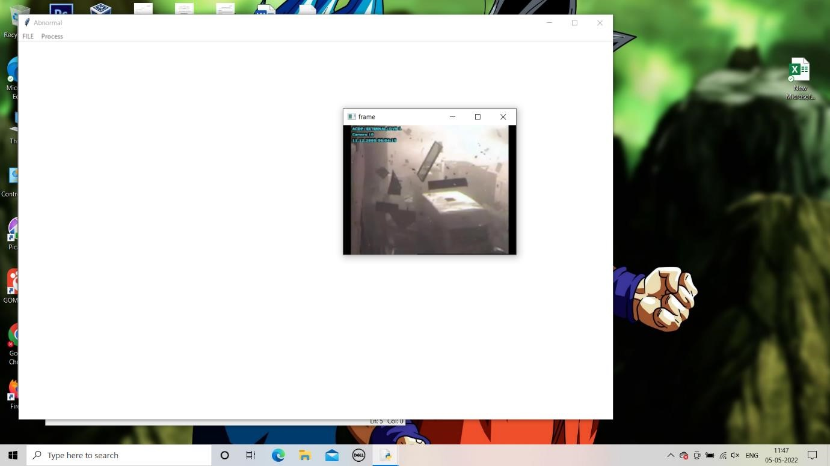

STEP 5: After taking the input sample video it plays the video completely and the frame process is started and all frames are collected and displayed in the second image.

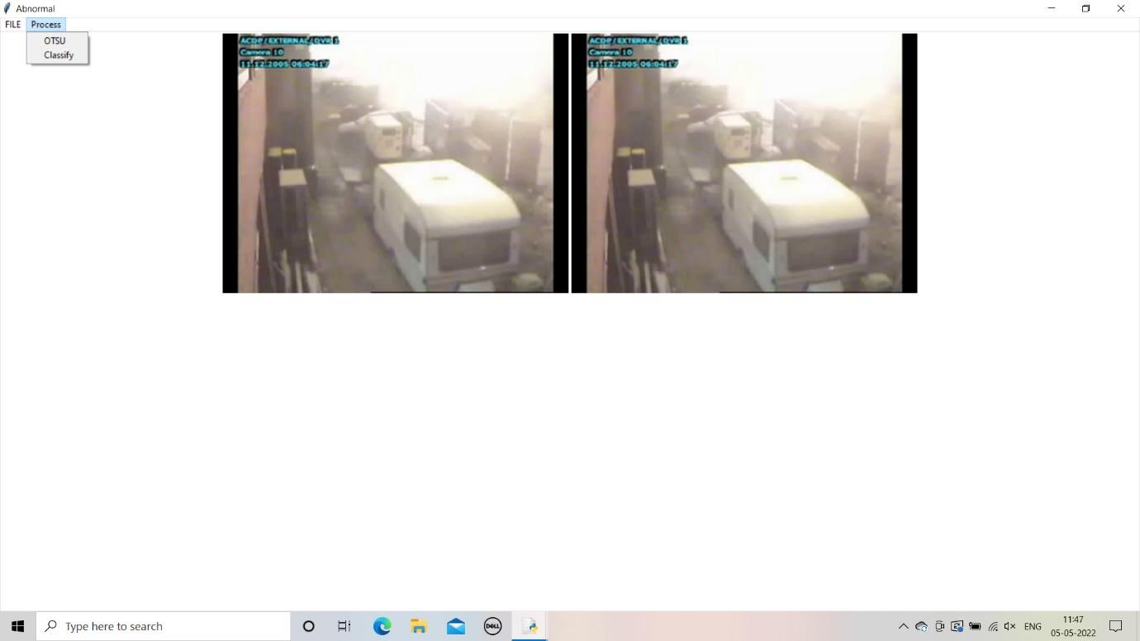

*fig 6.5 Frame processing started*

STEP 6: LATER we have to click on OTSU then all the frames are checked

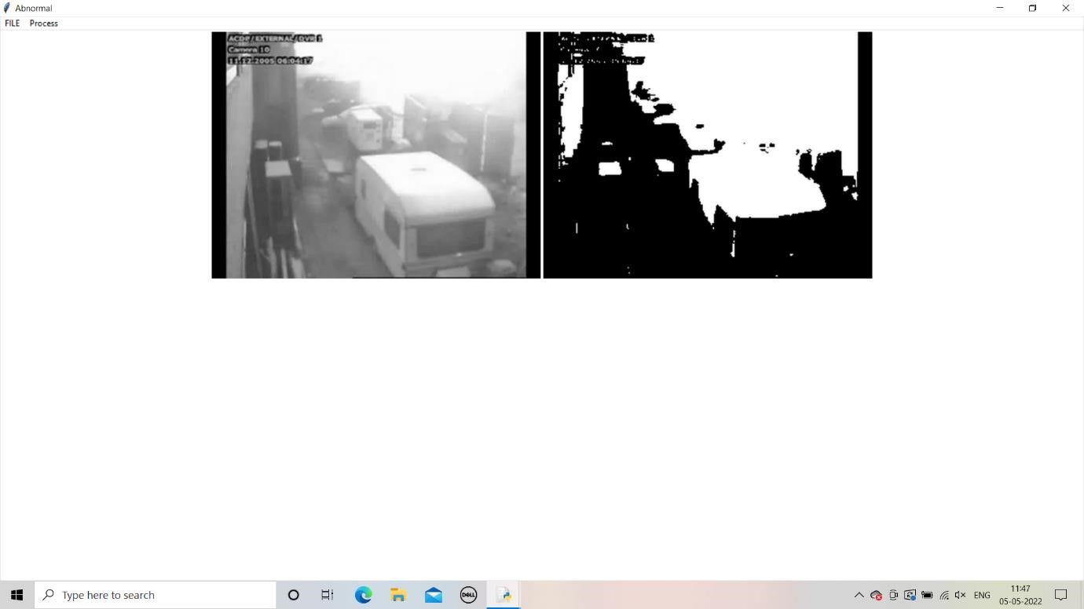

STEP 7: AFTER CLICK OTSU then we have click on classify then frame process is started and by using Resnet 18 among the all the frames in the video should be classify and give the output frames of Anomaly happened in the video.

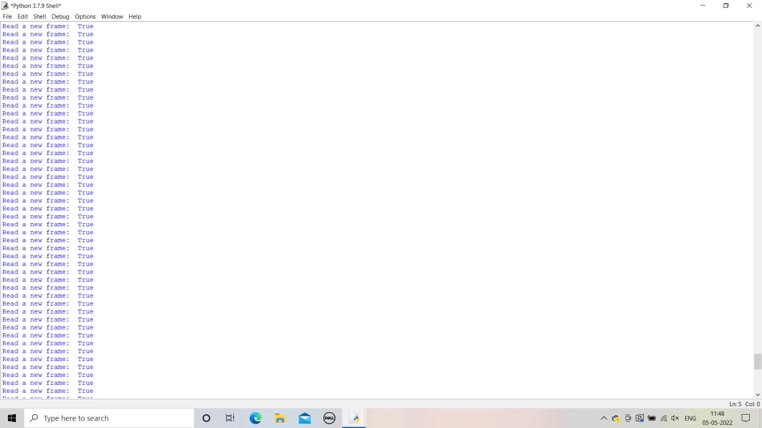  *fig 6.6 Analysing each frame*

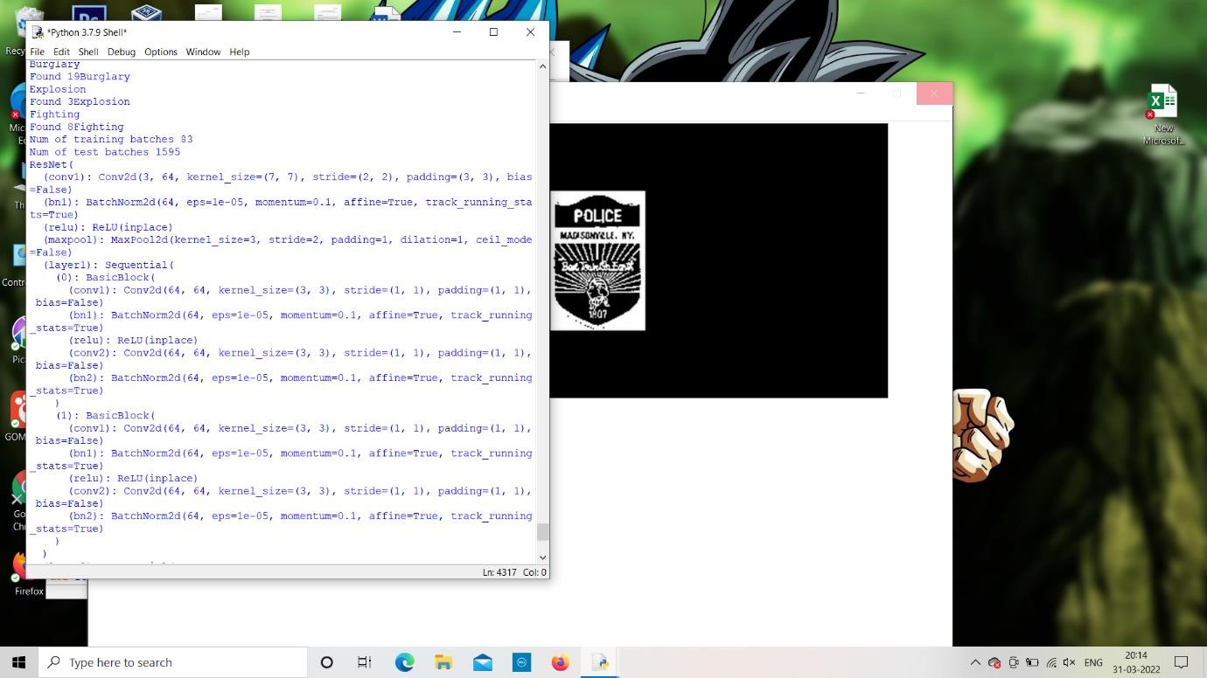

*fig 6.7 Each frame was processed using ResNet 18*

STEP 8: Later that the frame process is completed then it it occurs total of 80 steps and the occurs and value loss we can see for every 20 steps and then the result is displayed with the respective frames that anomaly occurs in given sample input video. Accuracy and value loss is not same for every time it have change due to if it reads more frames it may change.

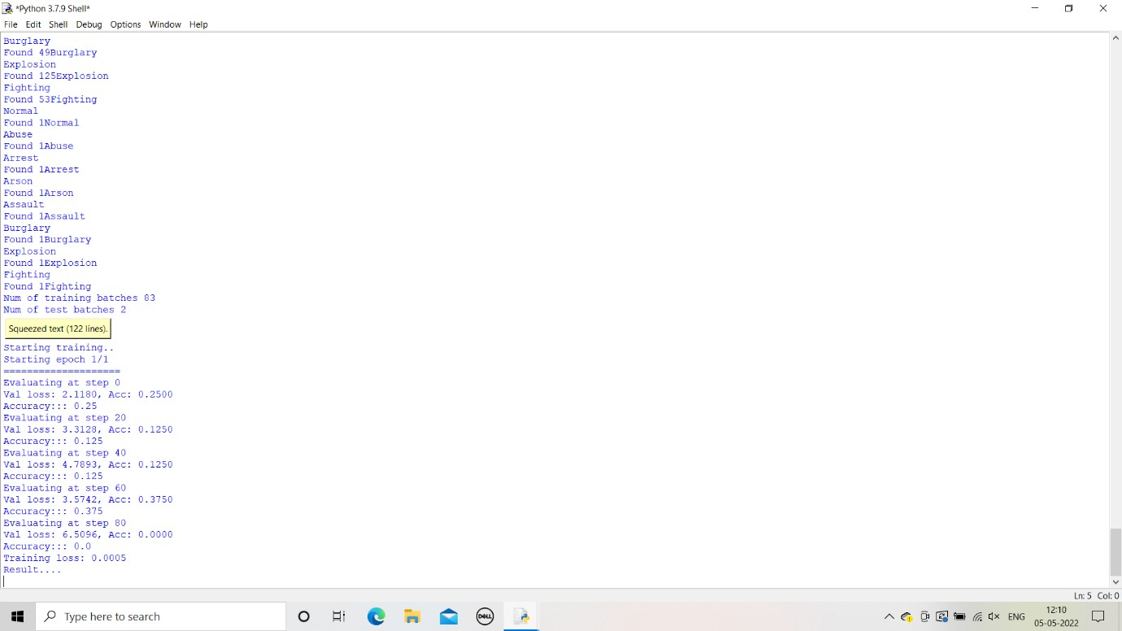  *fig 6.8 Evaluating Accuracy and value loss*

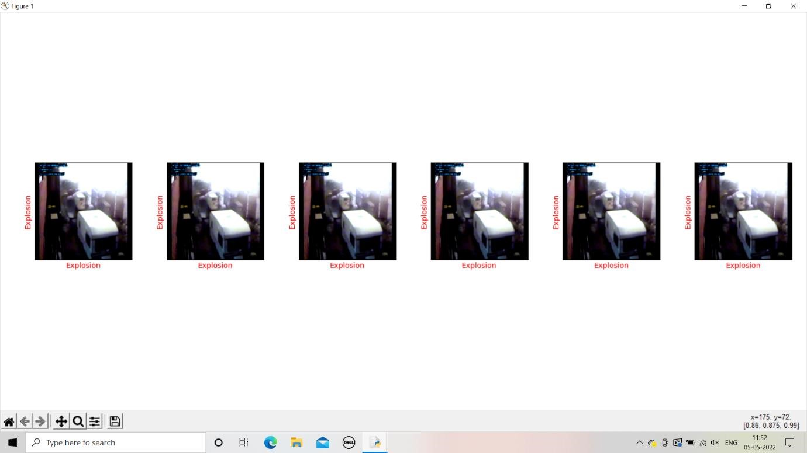

*fig 6.9 Results of Anomaly detection in surveillance video*

**CHAPTER 7**

## CONCLUSION AND FUTURE WORKS

This exploration works basically revolves around the affirmation of different peculiarities from perception accounts to discard a lot of human intervention. This study proposes a robotized significant learning-based approach for veritable weird development affirmation. This work is coordinated considering the way that not much work has been finished as such far on the affirmation of various peculiarities and for the most part researchers address simply twofold gathering i.e., either a video is standard or containing irregularity. Our expansive composing review moreover shows that why significant learning-based approaches have pervasiveness over excellent based approaches for the extraction of components from accounts. The proposed concentrate on gives a changed, pre-arranged 3D Convents plan that outmanoeuvres on the as of late declared approaches. This 3D model is used to really remove both spatiotemporal components from surveillance accounts. The concentrate furthermore addresses the meaning of the presence of edge level checking for better learning of spatiotemporal components in a semi-oversaw manner. Besides, this work has shown the importance of spatial increment to secure better outcomes while setting up a significant plan. The proposed technique is applied to the huge degree UCF Crime dataset. The tests coordinated on this dataset show that the aligned 3DConvNets outmanoeuvres the ongoing state of-craftsmanship sporadic development affirmation approaches with respect to precision. The proposed work furthermore gives a pilot find out about different classes of the UCF Crime dataset and inspected it cut off points for the sporadic activity affirmation task that will be helpful for future work on this dataset.

## REFERENCES

1. <https://dl.acm.org/doi/abs/10.1007/s11042-021-10570-3>
2. [https://www.researchgate.net/publication/281447377_Human](https://www.researchgate.net/publication/281447377_Human_Action_Recognition_using_Factorized_Spatio-Temporal_Convolutional_Networks_FstCN)

[_Action_Recognition_using_Factorized_Spatio-](https://www.researchgate.net/publication/281447377_Human_Action_Recognition_using_Factorized_Spatio-Temporal_Convolutional_Networks_FstCN)

[Temporal_Convolutional_Networks_FstCN](https://www.researchgate.net/publication/281447377_Human_Action_Recognition_using_Factorized_Spatio-Temporal_Convolutional_Networks_FstCN)

1. <https://ieeexplore.ieee.org/document/7410867>
2. <https://zh.booksc.eu/book/49502846/292269>
3. [https://journalofbigdata.springeropen.com/articles/10.1186/s4](https://journalofbigdata.springeropen.com/articles/10.1186/s40537-021-00496-w)

[0537-021-00496-w](https://journalofbigdata.springeropen.com/articles/10.1186/s40537-021-00496-w)